Node JS Practical

# Practical 1

**Aim :** Write a Program to pass a message "Welcome to Node JS World".

**LINE OF CODE :**  console.log("Welcome to Node JS World");

**Output :**

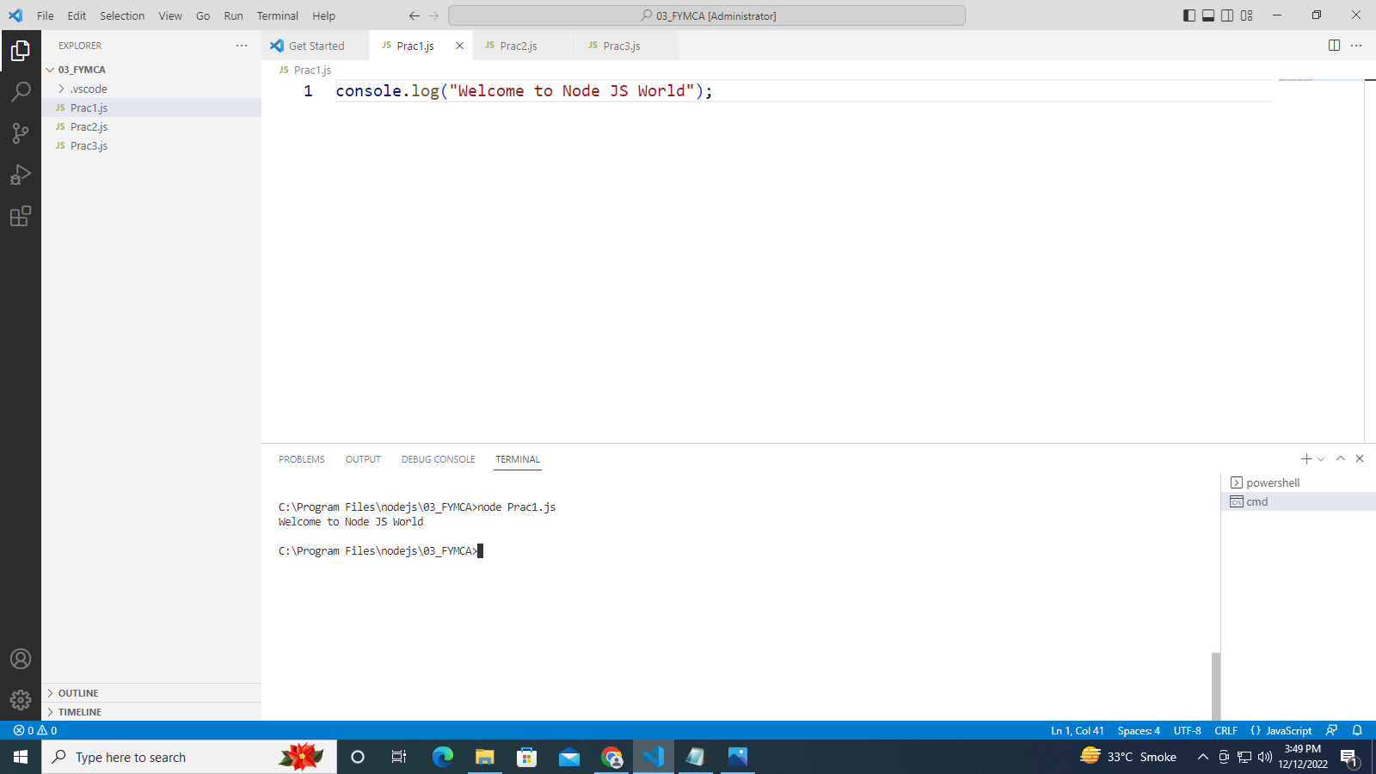

# Practical 2

**Aim :** Write a program to demonstrate Node JS functions.

**LINE OF CODE : :**

function amir (x,y)

{

return x*y;

}

var result = amir(9,8);

console.log(result);

**Output :**

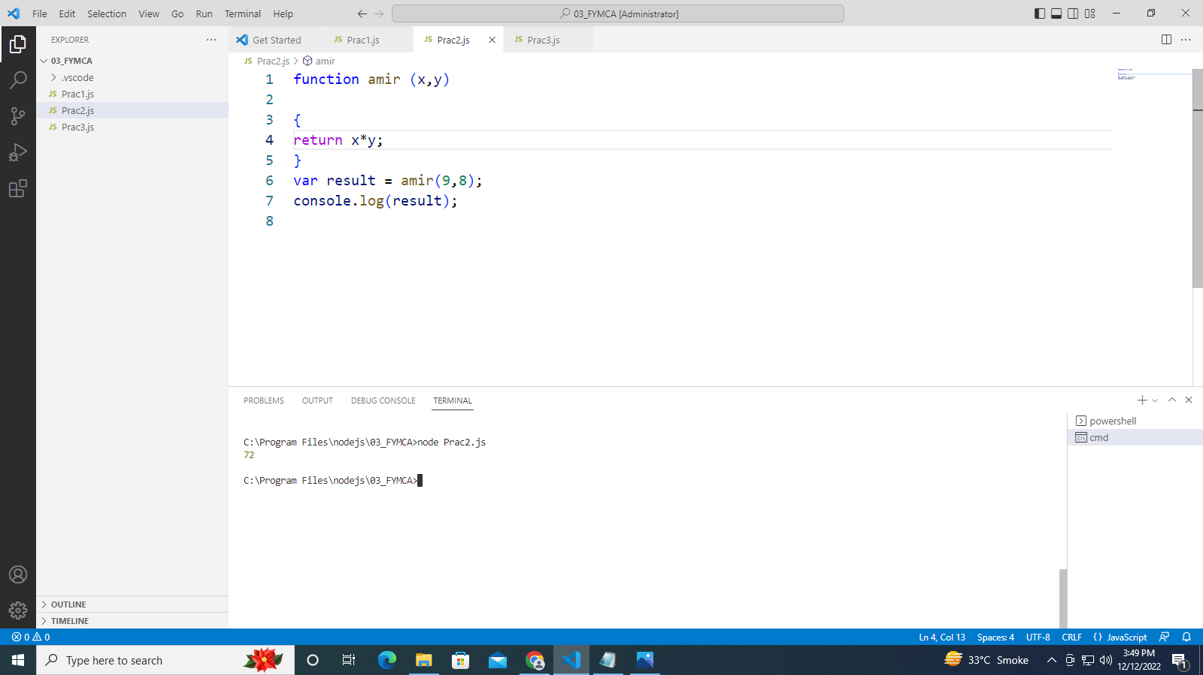

# Practical 3

**Aim :** Write a program to demonstrate Callback function - Anonymous Function Node JS

**LINE OF CODE :**

const message = function ()

{

console.log("This is the Practical LAB for FYMCA of web technologies");

}

setTimeout(message,10000);

//callback function as an arrow function

setTimeout(() => {

console.log("This is 2nd day practical");

**Output :**

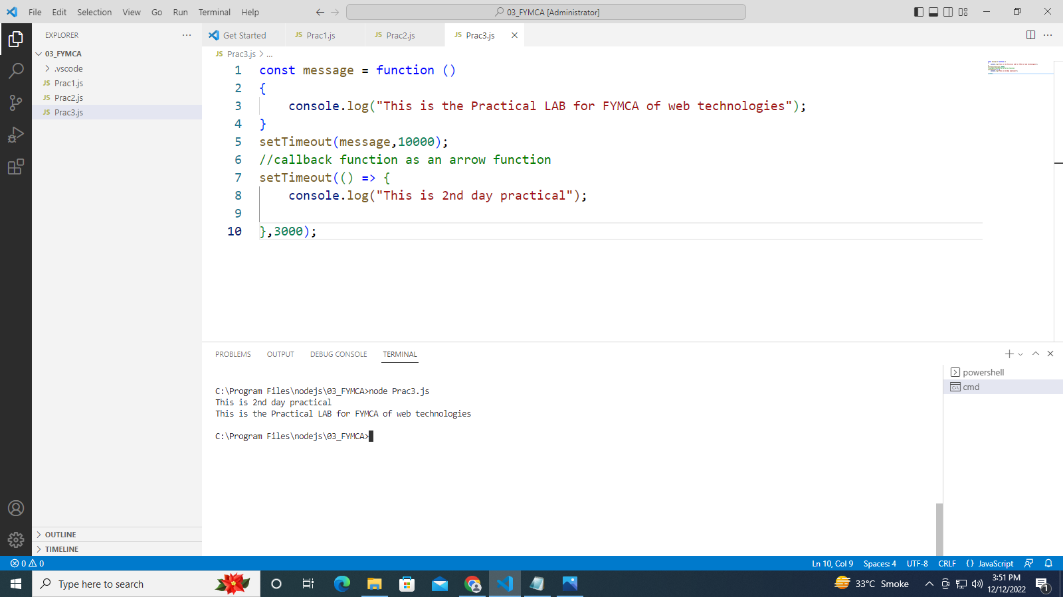

# Practical 4

**Aim :** Write a program to pass an argument using callback function to another function using node js.

**LINE OF CODE :**

// A CALLBACK FUNCTION PASSED AS AN ARGUMENT TO ANOTHER FUNCTION

function display_result (par)

{

console.log(par);

}

function calculate (a,b, mycallback)

{

let sum = a + b;

mycallback(sum);

}

calculate (100,200, display_result);

**Output :**

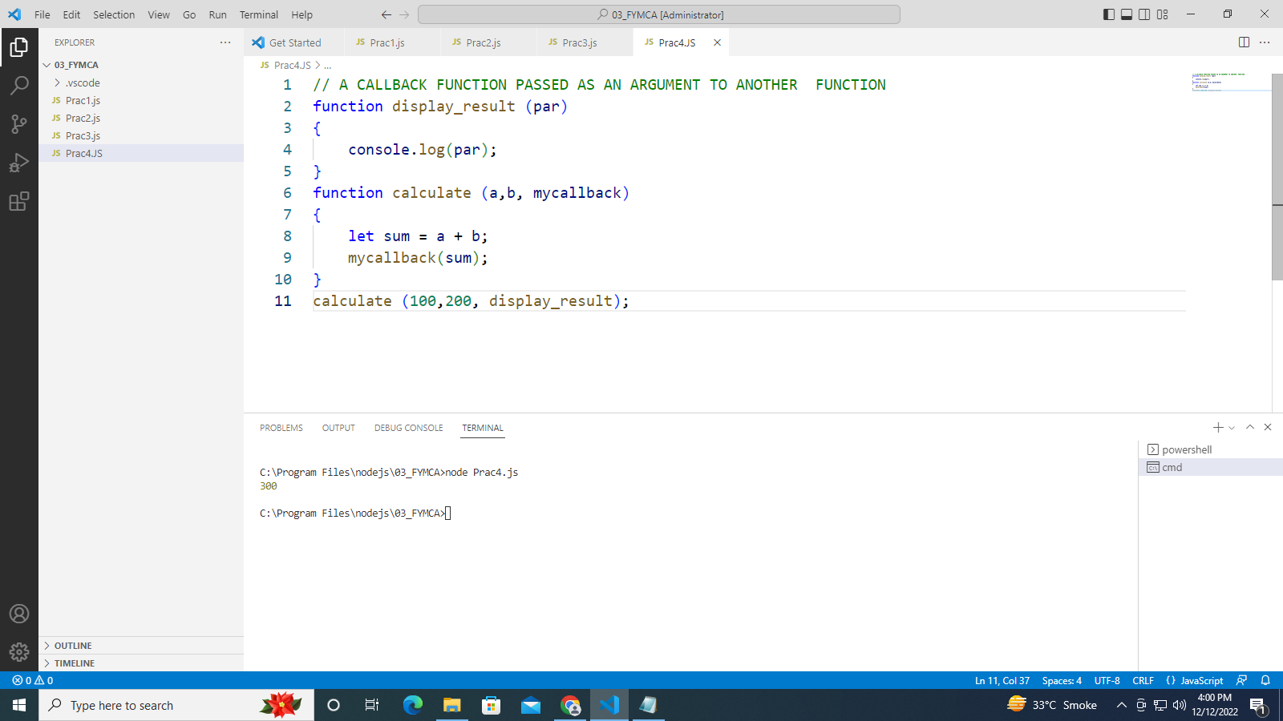

# Practical 5

**Aim 5.1 :** Write a program to demonstrate Import using NODE JS modules.

**LINE OF CODE :**

//understand how to call the modules

var dt=require('./Prac5.2_Export.js');

console.log(dt.myDateFun());

**Output :**

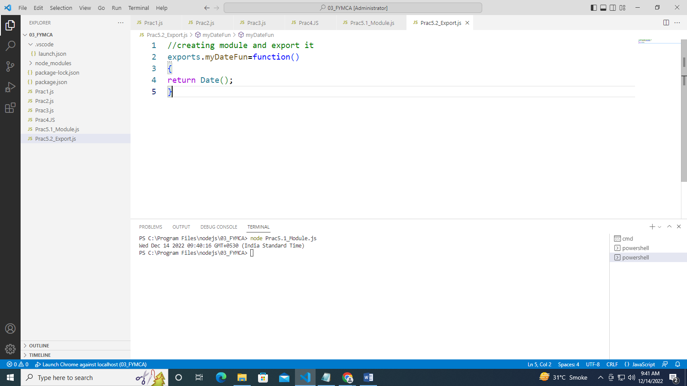

**Aim 5.2 :** Write a program to demonstrate Export using Node JS Module

**LINE OF CODE :**

//creating module and export it

exports.myDateFun=function()

{

return Date();

}

**Output :**



# Practical 6

**Aim :** Write a program to demonstrate various NODE JS EVENTS

**Description** : The eventEmitter is a module that facilitates communication or interaction between objects node.

in the eventEmitter there are methods like :

(1) addListener(event,listener)

(2) on(event, listener)

(3) once(event, listener)

(4) removeListener(event, listener)

(5) removeAllListener([event])

**LINE OF CODE :**

// step 1 importing event

const events = require("events");

// step 2 creating an Event emitter object

const eventEmitter = new events.EventEmitter();

//write a function of event 1

function listner1() {

console.log("Event recevied by Listner 1");

}

//write a function of event 2

function listner2

() {

console.log("Event recevied by Listner 2");

}

// step 3 adding listener through addlistener or on

eventEmitter.addListener("write", listner1);

eventEmitter.on("write", listner2);

// step 4 emiting event

eventEmitter.emit("write");

console.log(eventEmitter.listenerCount("write"));

// step 5 removing listener

eventEmitter.removeListener("write", listner1);

console.log("Listener 1 is removed");

eventEmitter.emit("write");

console.log(eventEmitter.listenerCount("write"));

console.log("Program Ended");

**Output :**

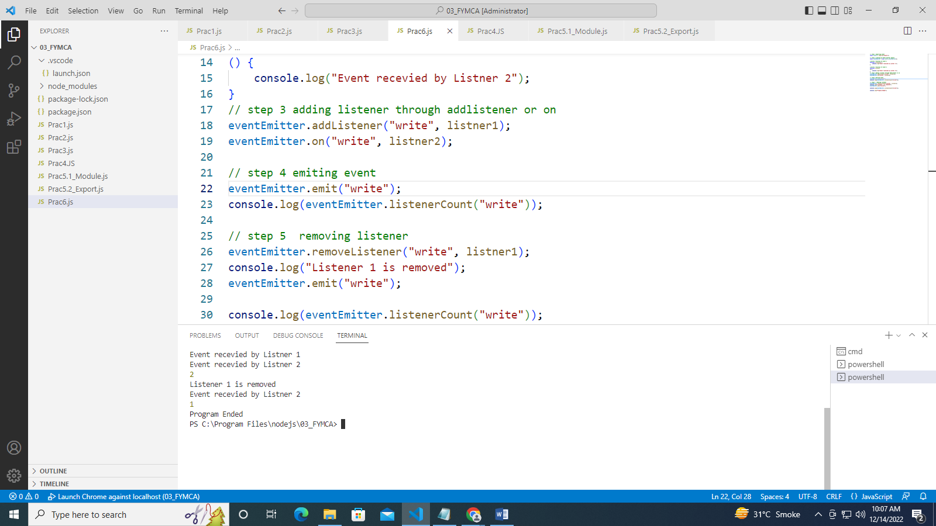

# Practical 7

**Aim :** Create an HTTP server and perform operations on it.

**LINE OF CODE :** Prac7_sysdate

exports.myDateFun=function()

{

return Date();

}

**LINE OF CODE :** Prac7b_HTTPServer

var http=require('http');

var dt=require('./Prac7_sysdate');

http.createServer(function(req,res) {

res.writeHead(200,{'Content-Type':'text/html'});

res.write("The date and time is currently:"+dt.myDateFun());

res.end();

}).listen(8080);

**Output :**

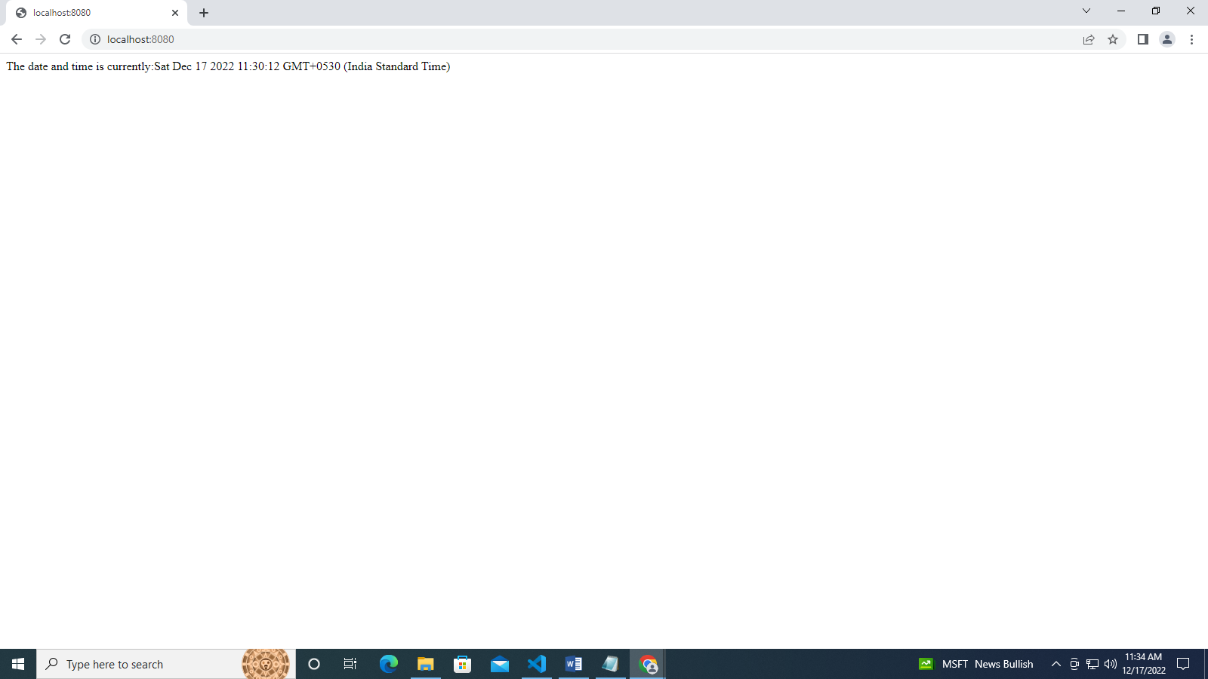

**LINE OF CODE :** Prac7a_HTTPServer

//understand how to create the http server module

var http=require('http');

var server=http.createServer(function(req,res)

{

res.write("This is the http server");

//res.end("This is the http server");

});

server.listen(8080);

console.log("server is running");

**Output :**

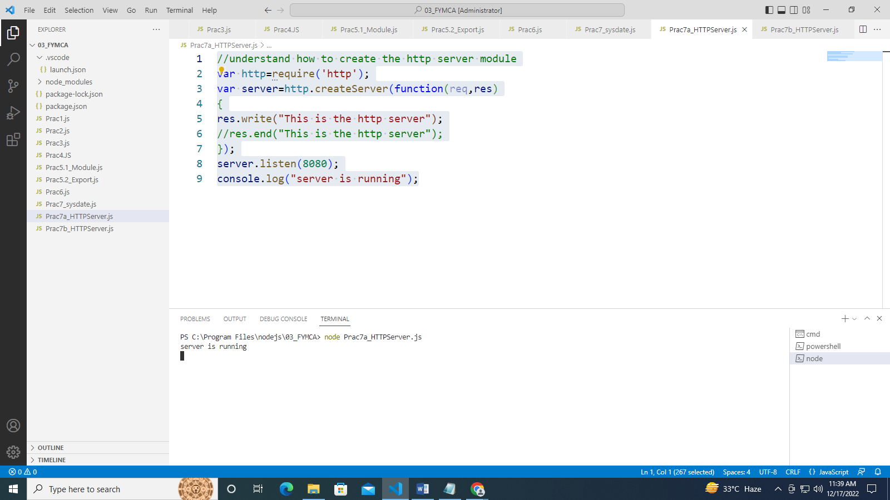

Practical 8

**Aim :** Write a program to demonstrate Routing through HTTP Server

**LINE OF CODE :**

//understand routing through http server

var http=require('http');

var server=http.createServer(function(req,res){

if(req.url=='/')

{

res.writeHead(200,{'content-Type':'text/html'})

res.write("<h1>Home Page</h1>");

res.write("<h2>Hello Students</h2>");

res.write("<h2>This is a home page for students</h2>");

res.end();

}

else if (req.url=='/office')

{

res.writeHead(200,{'content-Type':'text/html'})

res.write("<h1>Office Page</h1>");

res.write("<h2>This is a office page</h2>");

res.end();

}

else if (req.url=='/login')

{

res.writeHead(200,{'content-Type':'text/html'})

res.write("<h1>Student Login Page</h1>");

res.write("<h2>This is a Login page for students</h2>");

res.end();

}

else if (req.url=='/gallary')

{

res.writeHead(200,{'content-Type':'text/html'})

res.write("<h1>Gallary Page</h1>");

res.write("<h2>This is a gallary page for students</h2>");

res.end();

}

else if (req.url=='/ContactUs')

{

res.writeHead(200,{'content-Type':'text/html'})

res.write("<h1>ContactUs Page</h1>");

res.write("<h2>This is a Contact Us page for students</h2>");

res.end();

}

else

{

res.write("<h1>Invalid Page</h1>");

res.end();

}

});

server.listen(8080);

console.log("server is running");

**Output :**

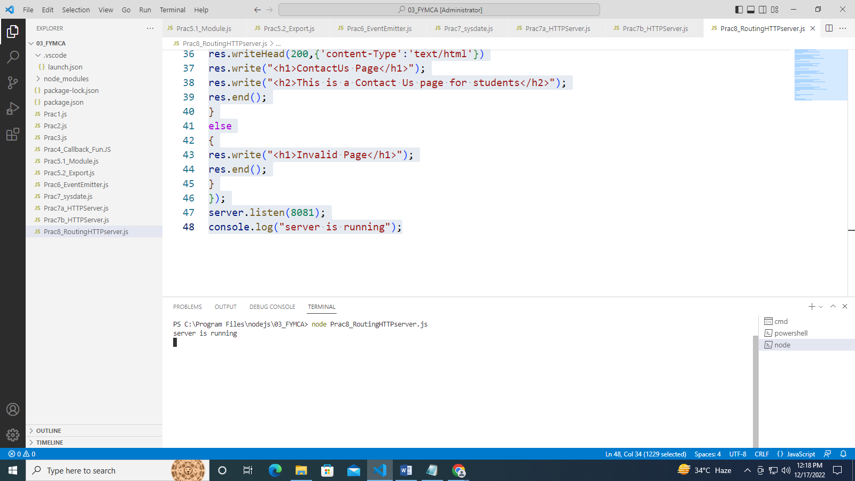

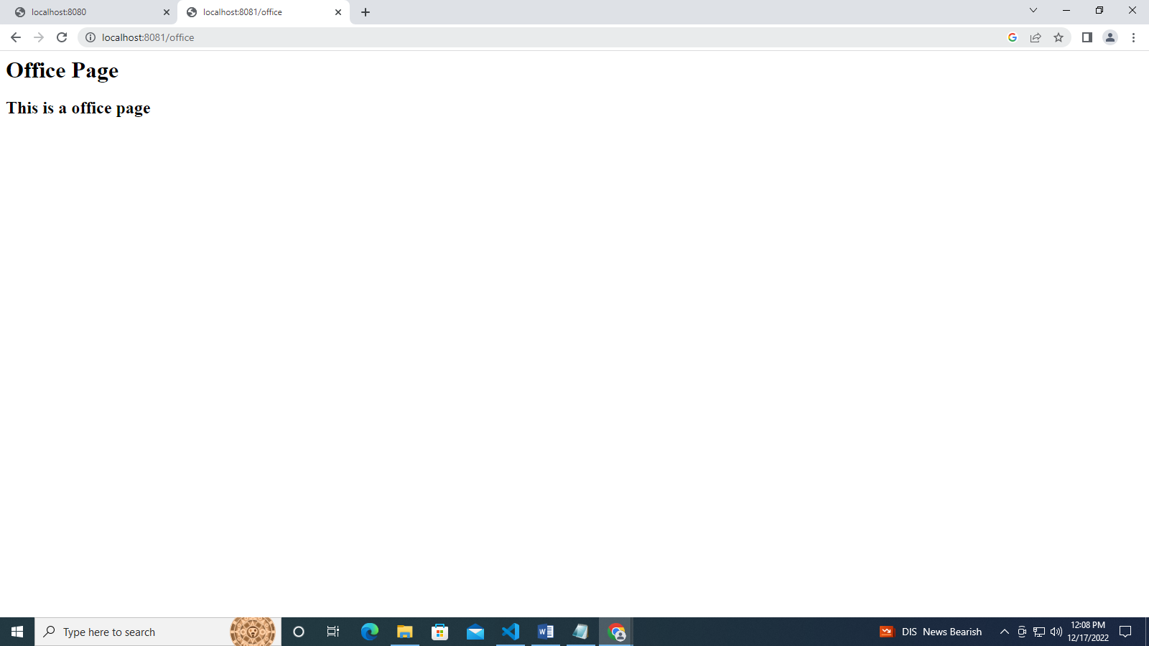

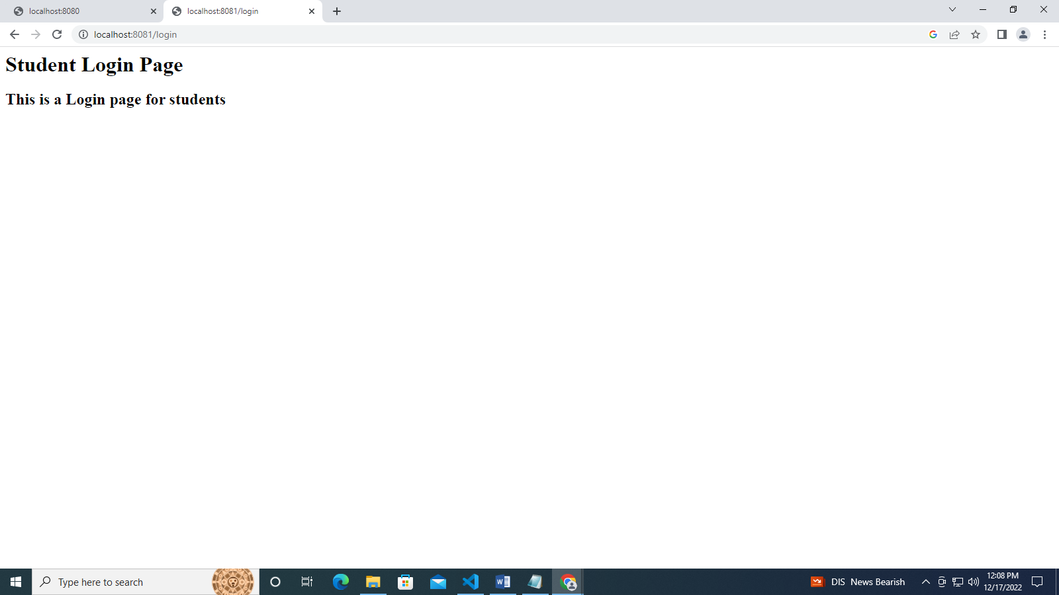

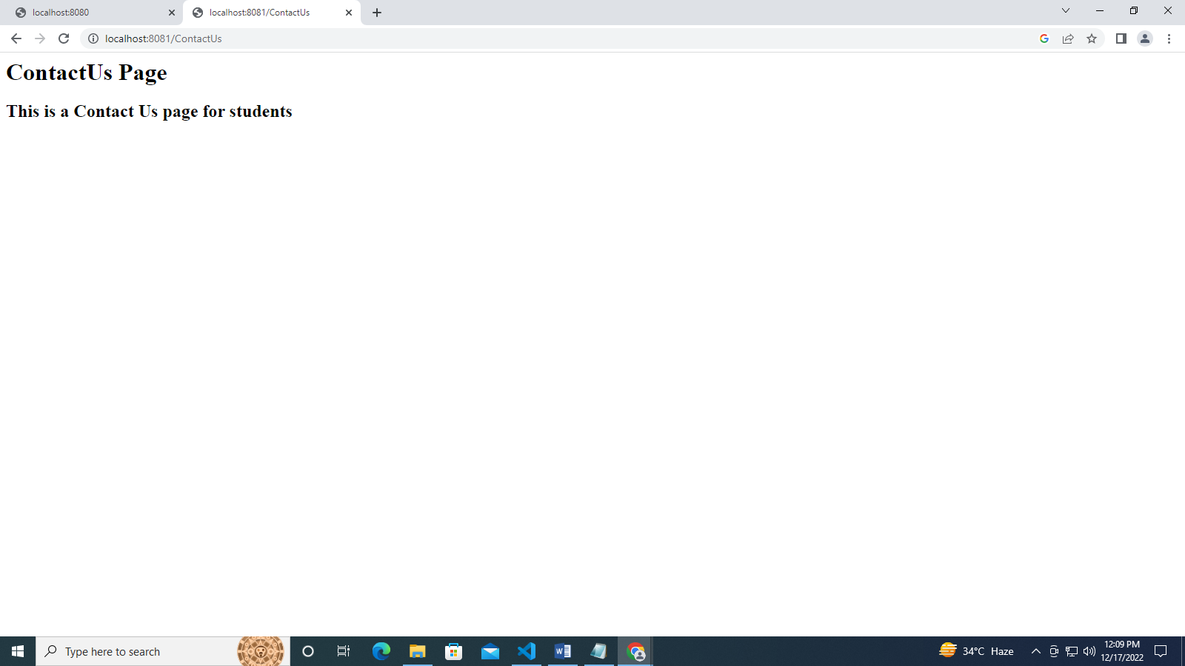

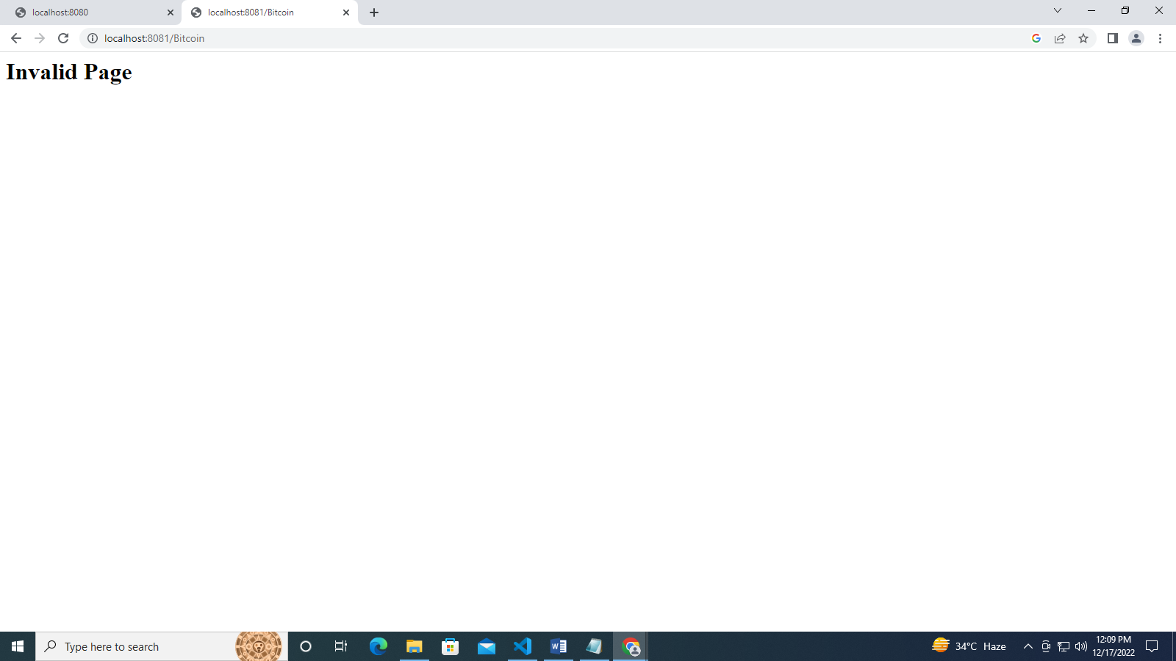

# Practical 9

**Aim :** Write a program to demonstrate custom event using Node JS

**LINE OF CODE :**

//Import events module

const events = require('events');

//create an event emitter object

const eventEmitter = new events.EventEmitter();

eventEmitter.on("connection", handleConnectionEvent);

function handleConnectionEvent()

{

console.log("Connection Made!");

}

eventEmitter.emit("connection");

eventEmitter.emit("connection");

eventEmitter.emit("connection");

eventEmitter.emit("connection");

console.log("End of Program");

**Output :**

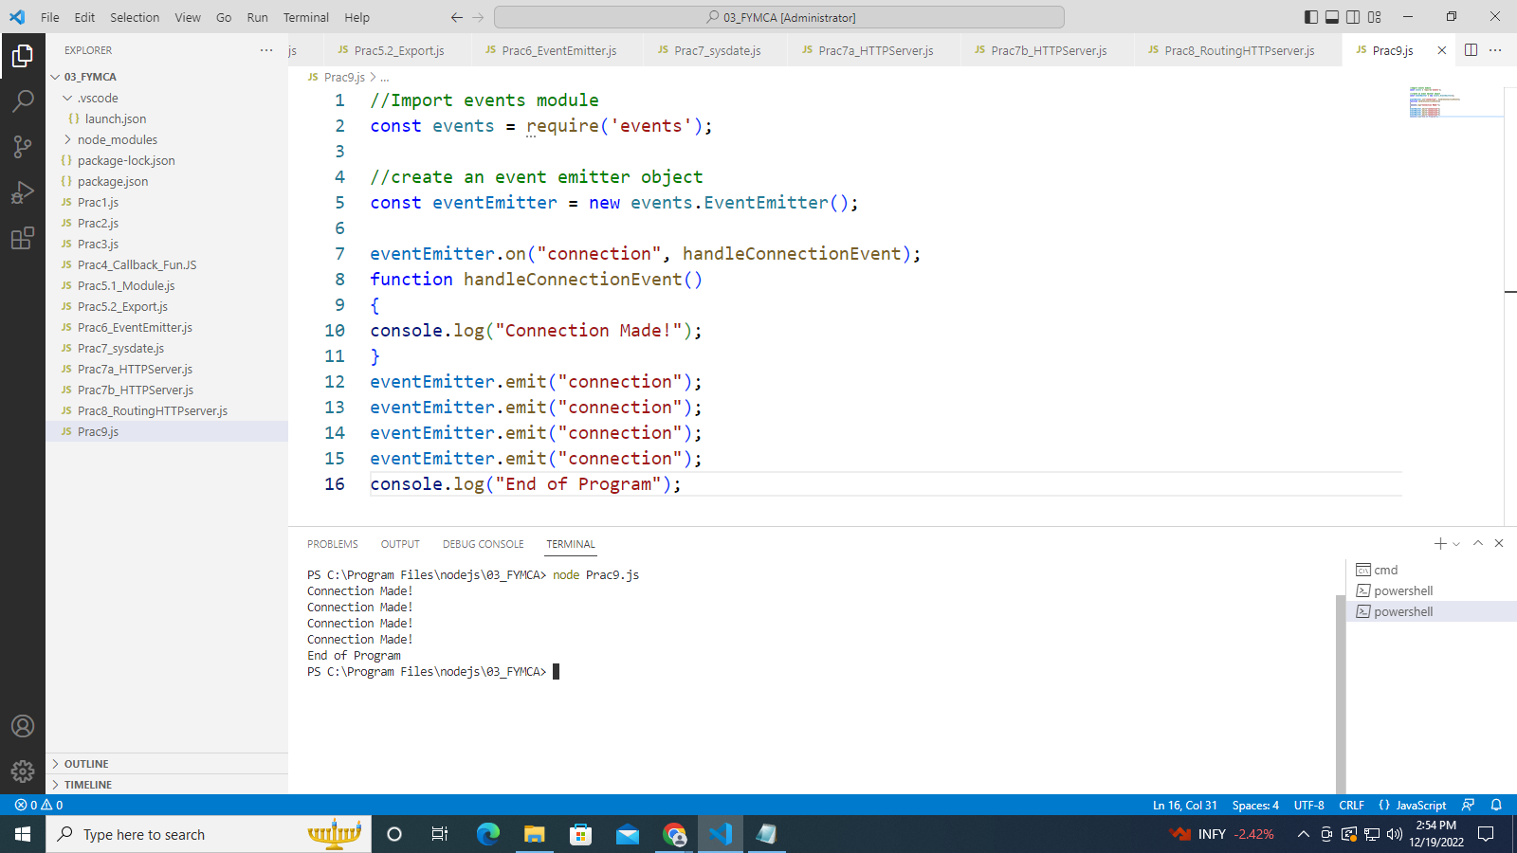

# Practical 10

**Aim :** Write a program in node.js using file handling to demonstrate all basic file operations (Create, Write, Read, Delete and Buffer)

**LINE OF CODE :**

**Read Operation**

**(Prac10A_Read.js)**

//node js file system  
//reading file  
var fs = require('fs');  
fs.readFile('operation.txt', function (err, data) {  
if (err) throw err;  
console.log(data.toString());  
});

Cryptocurrency is the future currency of the universe.

Currently it's collasping and its the best time to buy and hold it.

I predict in next 2 years Bitcoin will cross $100k barrier.

Etherium is the next best alternative to btc.

Crypto never sleeps and it can't be stopped.

**Output :**

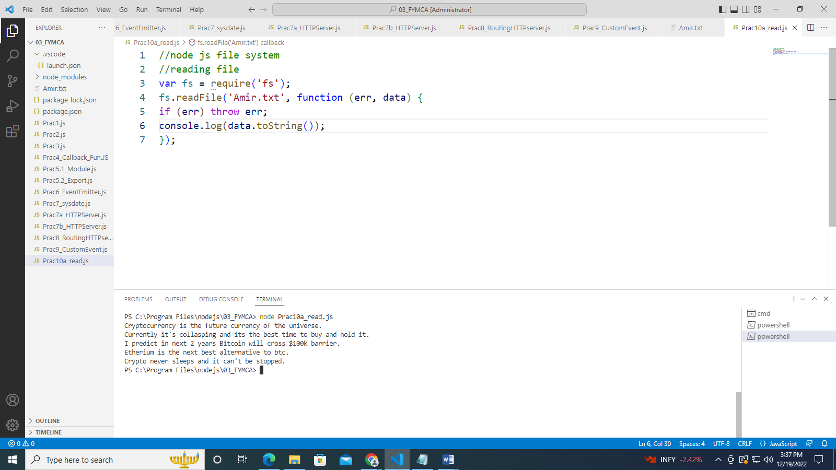

**Write Operation**

**(Prac10B_Write.js)**

var fs = require('fs');  
fs.writeFile('Myfile.txt', ‘BTC is king', function (err)   
{  
if (err)  
console.log(err);  
else  
console.log('Write operation complete.');  
});

**Output :**

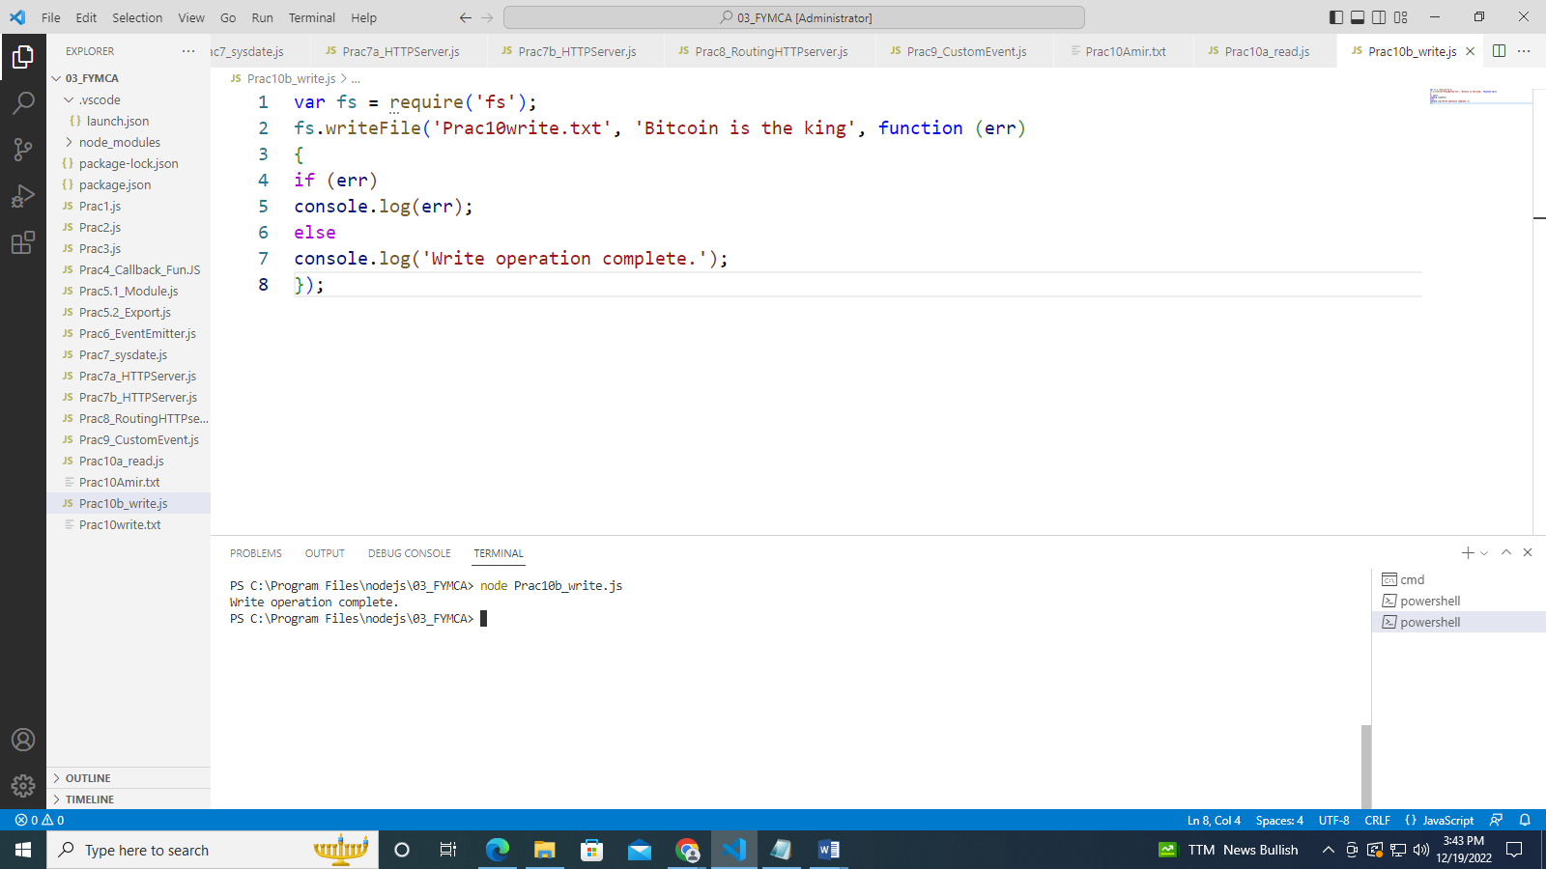

**Buffer Operation**

**(Prac10c_Buffer.js)**

var fs = require('fs');  
fs.open('Myfile.txt', 'r', function (err, fd) {  
if (err) {  
return console.error(err);  
}  
var buffr = new Buffer(10240);  
fs.read(fd, buffr, 0, buffr.length, 0, function (err, bytes) {  
if (err) throw err;  
// Print only read bytes to avoid junk.  
if (bytes > 0) {  
console.log(buffr.slice(0, bytes).toString());  
}  
// Close the opened file.  
fs.close(fd, function (err) {  
if (err) throw err;  
});  
  
});  
});

**Output :**

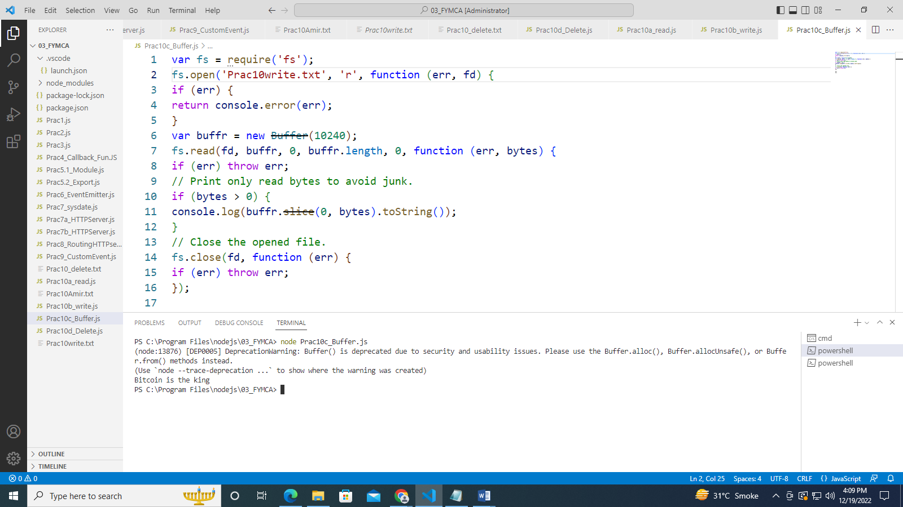

**Delete Operation**

**(Prac10d_Delete.js)**

var fs= require('fs');  
fs.unlink('delete.txt',function(){  
console.log('delete operation complete.');  
});

**Output :**

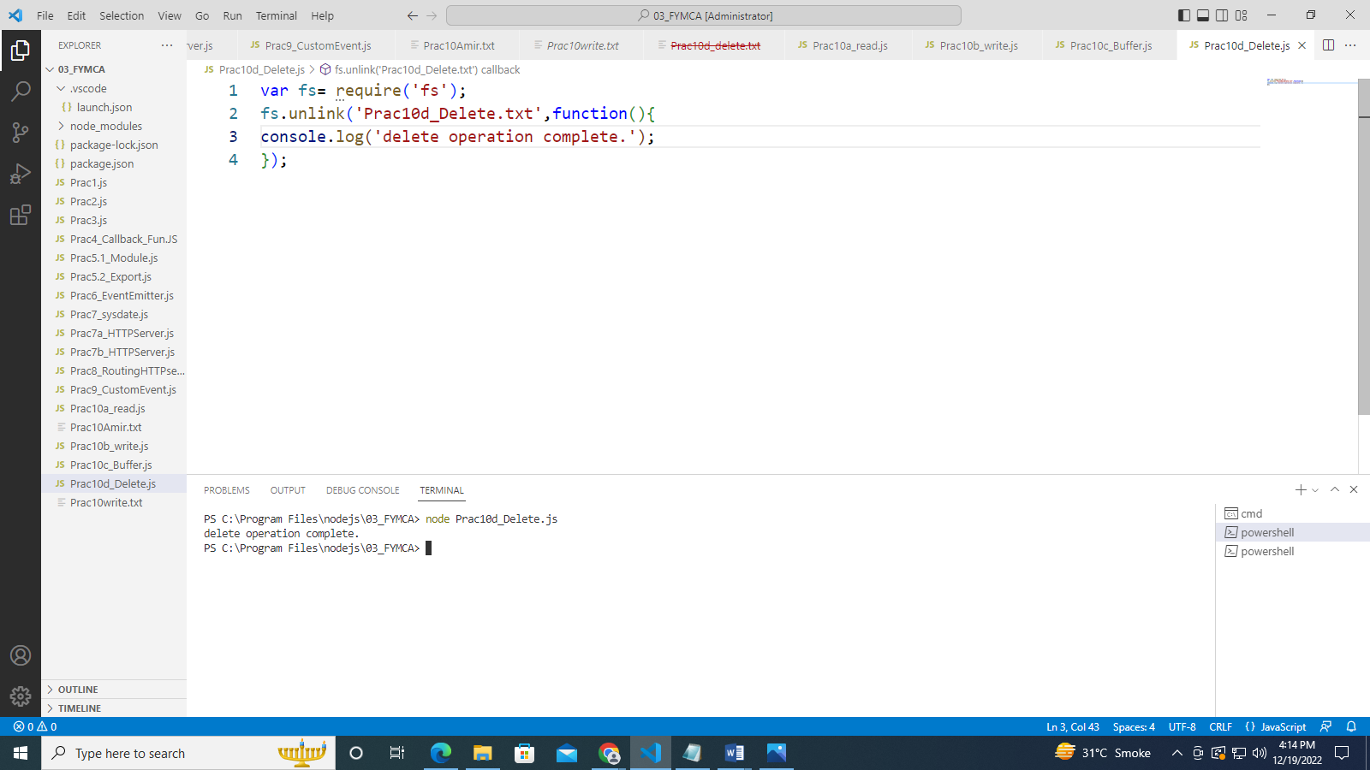

# Practical 11

**Aim :** Create an application to establish an connection with MySQL Database and perform basic database operations on it.

**Step 1:**  Establish a connection.

**Step 2**: Creating database.

**Step 3:**  Create table in the database (create table with primary key)

**Step 4:** Inserting data into the table.

**Step 5:** Fetching data from the table.

**Step 6:** Update data of the table.

**Step 7:** Deleting data from the table.

**LINE OF CODE :**

**[Prac11_Connect.js]**

var mysql=require('mysql2');

var con=mysql.createConnection({

host:"localhost",

user:"root",

password:""

//port:3306,

});

con.connect(function(err){

if(err) throw err;

console.log("Connected!");

});

**Output :**

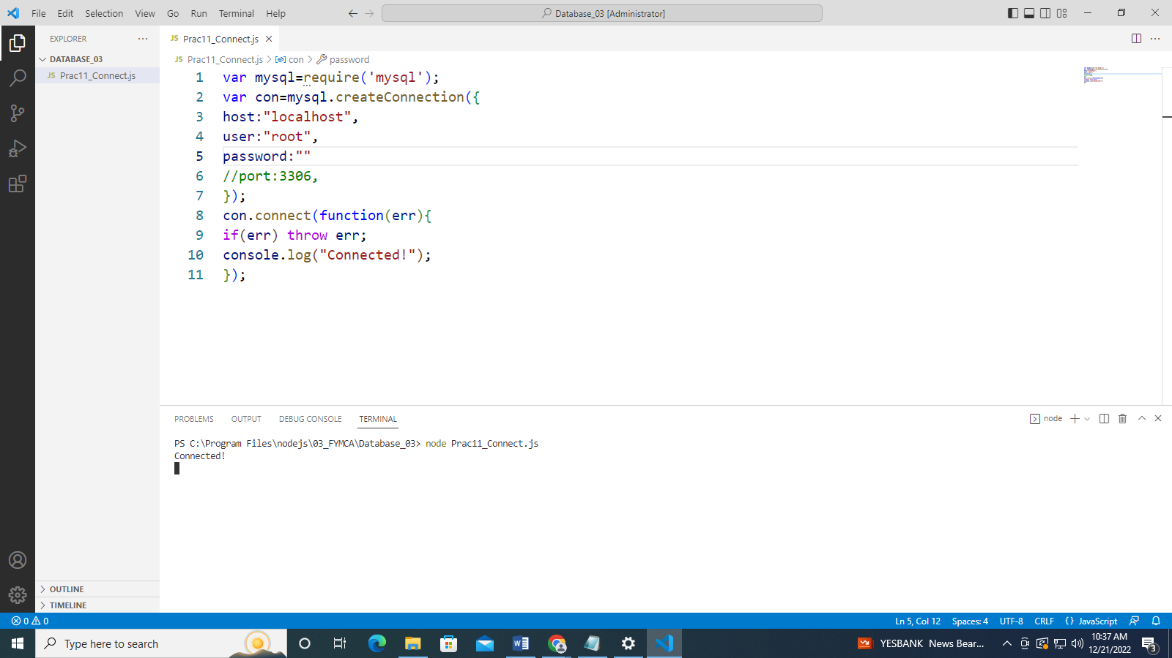

**[Prac11_CreateDatabase.js]**

var mysql=require('mysql');

var con=mysql.createConnection({

host:"localhost",

user:"root",

password:""

//port:3306

});

con.connect(function(err){

if(err) throw err;

console.log("Connected!");

con.query("CREATE DATABASE 03_FYMCA", function(err,result){

if (err)

{

throw err;

}

console.log("Database Created");

});

});

**Output :**

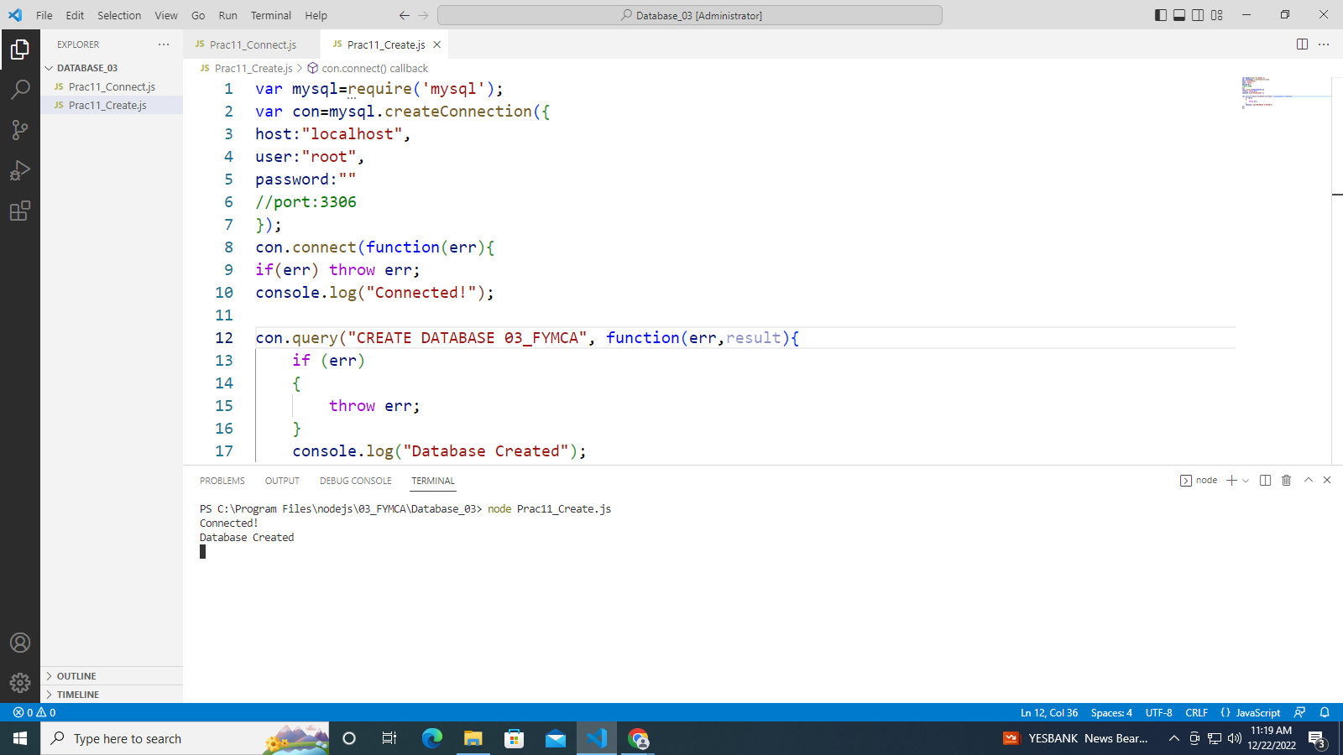

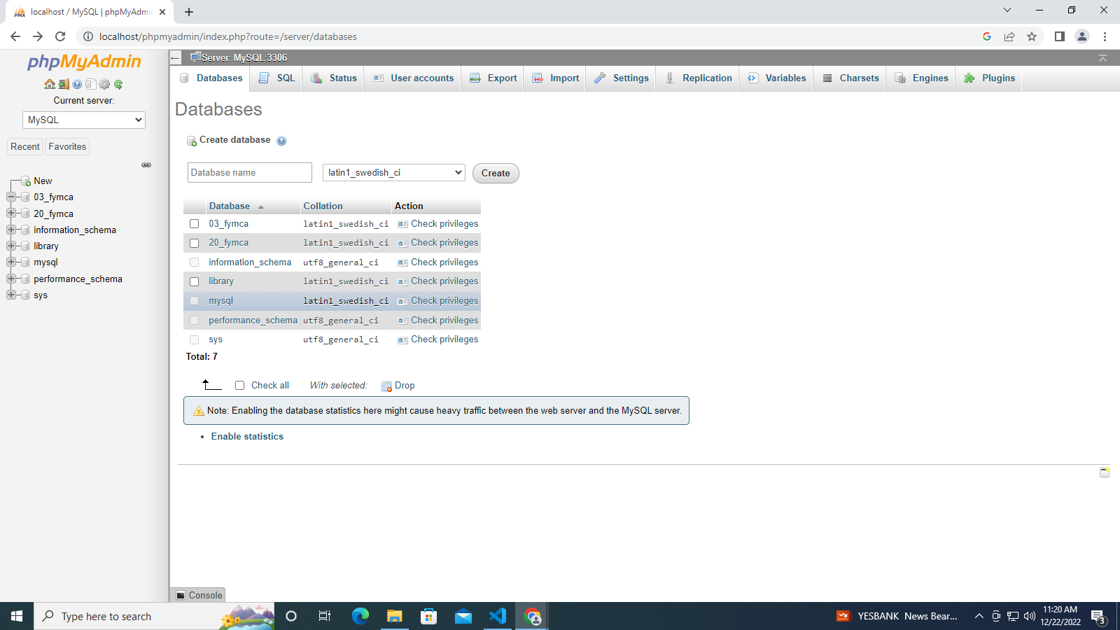

**[Prac11_CreateTable.js]**

var mysql=require('mysql');

var con = mysql.createConnection({

host:"localhost",

user:"root",

password:"",

database:"19_FYMCA"

//port:"3306"

});

con.connect(function(err){

if(err) throw err;

console.log("Connected");

});

var sql="create table students(rollNo int(50),name varchar(255), age varchar(100),

address varchar(100),email varchar(100))";

con.query(sql, function(err,result){

if(err) throw err;

console.log("Table Created");

});

**Output :**

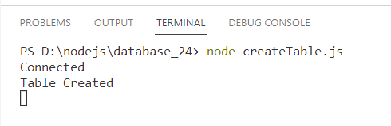

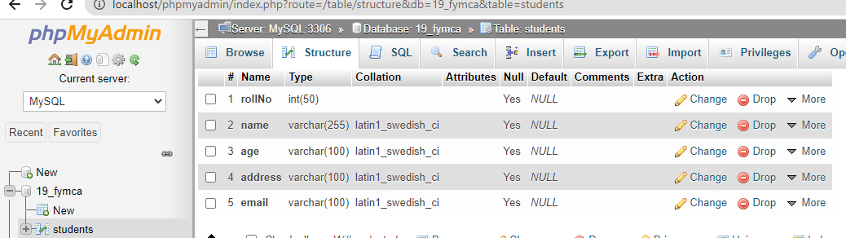

**[Prac11_TablePrimary.js]**

var mysql=require('mysql');

var con = mysql.createConnection({

host:"localhost",

user:"root",

password:"",

database:"03_fymca"

//port:"3306"

});

con.connect(function(err){

if(err) throw err;

console.log("Connected");

});

var sql="create table students(rollNo int(50),name varchar(255), age varchar(100),

address varchar(100),email varchar(100))";

con.query(sql, function(err,result){

if(err) throw err;

console.log("Table Created");

});

**Output :**

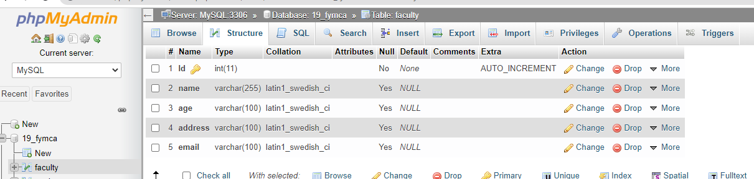

**[Prac11_Insertion.js]**

var mysql=require('mysql');

var con = mysql.createConnection({

host:"localhost",

user:"root",

password:"",

database:"19_FYMCA"

//port:"3306"

});

con.connect(function(err){

if(err) throw err;

console.log("Connected");

});

var sql="Insert into faculty (name,age,address,email) values ('Abdullah Jatu','21','Nallasopara','test@gmail.com'),('Moin Khan','21','Nallasopara','test@gmail.com'),

('Harsh Sanket','21','Nallasopara','test@gmail.com'), ('Jigar','21','Nallasopara','test@gmail.com'),('Dhyey','21','Nallasopara','test@gmail.com')";

con.query(sql, function(err,result){

if(err) throw err;

console.log("One record inserted");

});

**Output :**

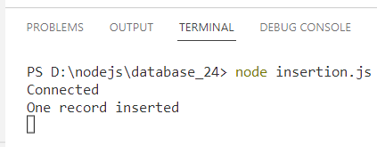

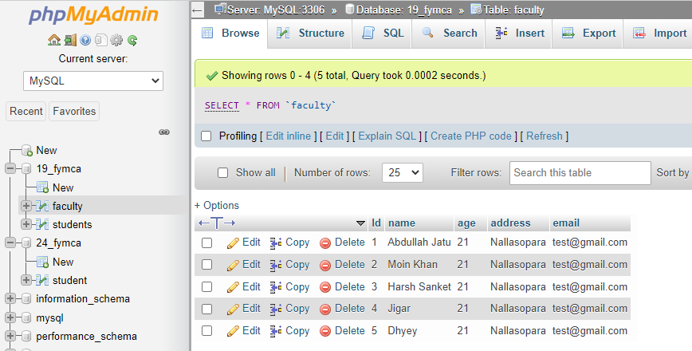

**[Prac11_Insertion.js]**

var mysql=require('mysql');

var con = mysql.createConnection({

host:"localhost",

user:"root",

password:"",

database:"19_FYMCA"

//port:"3306"

});

con.connect(function(err){

if(err) throw err;

console.log("Connected");

});

var sql = "Select id,email from faculty";

con.query(sql, function(err,result,feilds){

if(err) throw err;

console.log(result);

});

**Output :**

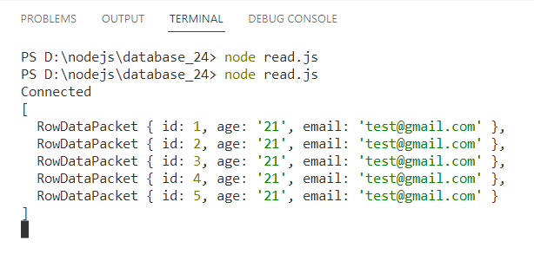

**[Prac11_Update.js]**

var mysql=require('mysql');

var con = mysql.createConnection({

host:"localhost",

user:"root",

password:"",

database:"19_FYMCA"

//port:"3306"

});

con.connect(function(err){

if(err) throw err;

console.log("Connected");

});

var sql = "Update faculty set name = 'Abdullah Khan' where name='Abdullah Jatu' ";

con.query(sql, function(err,result,feilds){

if(err) throw err;

console.log(result.affectedRows + " records updated");

});

**Output :**

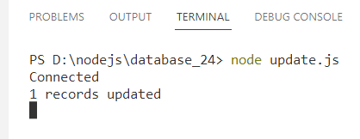

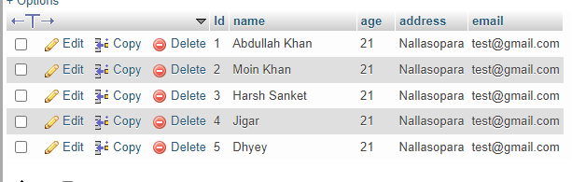

**[Prac11_Delete.js]**

var mysql=require('mysql');

var con = mysql.createConnection({

host:"localhost",

user:"root",

password:"",

database:"19_FYMCA"

//port:"3306"

});

con.connect(function(err){

if(err) throw err;

console.log("Connected");

});

var sql = "delete from faculty where name = 'Abdullah Khan' ";

con.query(sql, function(err,result,feilds){

if(err) throw err;

console.log(result.affectedRows + " No . of records deleted");

});

**Output :**

